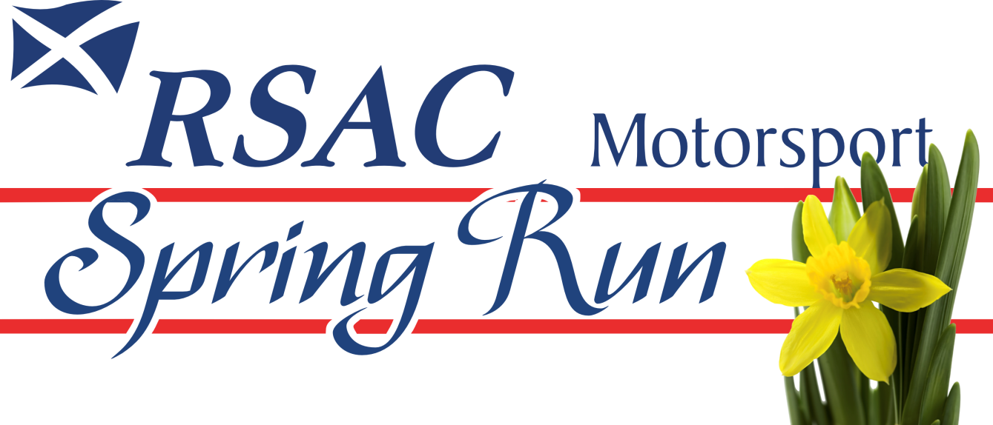
SUNDAY 7 APRIL 2024

FOREWORD

We have pleasure in welcoming participants to the RSAC Motorsport Spring Run. Once again we extend a warm welcome to all drivers and passengers, and look forward to meeting old friends and newcomers alike.

Following on the success of last year’s run, we are returning to Nuffield Health, Fitness and Wellbeing, Milngavie Club for the Start and Finish.

Our thanks are due to Nuffield Health, Fitness and Wellbeing, Milngavie Club for their continued support.

We look forward to receiving your entry and seeing you on Sunday 7 April.

The Organising Team

REGULATIONS

1 RSAC Motorsport Limited (the Organisers) will promote a Touring Assembly – The RSAC Motorsport Spring Run on Sunday 7 April 2024 under a Certificate of Exemption number 135345 issued by Motorsport UK. The event is held under the General Regulations of Motorsport UK (incorporating the provisions of the International Sporting Code of the FIA) and these Supplementary Regulations.

2 The event is open to sporting and saloon cars of any age and any other cars at the discretion of the Organisers. Starting order will be determined by the age of the vehicle, beginning with the oldest.

3 The event will start from Nuffield Health, Fitness and Wellbeing, Milngavie Club, Strathblane Road Milngavie G62 8HJ at 11.00 on Sunday 7April 2024 The finish of the run will take place at Nuffield Health, Fitness and Wellbeing, Milngavie Club where the cars are expected to arrive from approximately 15.00. Refreshments will be available at the start and finish.

4 The total distance of the run will be approximately 90miles for the long route and 40
for the short route
.
5 The run takes the form of a dignified presentation of vehicles. Cars may only carry the number of passengers permitted by the seating accommodation. Entrants must agree to maintain numerical order if required to do so.

6 Cars will be required to carry one official number plate supplied by the Organisers.
This plate will incorporate publicity for the Organisers of the event . Advertisements
or trade signs ,other than manufacturer’s standard emblems, must not be carried or
displayed on any car during the event

7 Cars and drivers may receive outside assistance during the run. However, cars may not be towed or conveyed on a float or other vehicle after the start.

8 The Organisers will not be responsible for damage to, or loss of, any car, its parts or accessories, or for any damage caused by any entrant or car, and any entrant by entering and driving, and a passenger by taking part, shall thereby waive any right of action at law against the Organisers for any damage sustained by him (her or them) in consequence of any act or omission on any part of the Organisers, or of the officials, representatives or agents with respect to these regulations or to the run or to any matter arising therefrom.

9 The maximum number of entries to be accepted is 80. The Organisers reserve the right to limit the number of entries, or to refuse an entry without giving a reason. They also reserve the right to abandon or postpone the run or any part thereof, if any circumstances arise which, in the opinion of the Board, render such a course desirable.

10 The event will include a Concours d’Elegance for which the following prizes, kindly presented by Ali McMillan, will be awarded:
Best Vintage Car
Best Classic Car
Best Jaguar Car
Other awards may be presented at the discretion of the Organisers.

11 The entry fee for the event will be £20.00 which will include a rally plate, road book and finisher’s certificate.

12 Officials of the Event:
Clerk of the Course Jonathan Lord
Entries Secretary Catherine Higgins
Judges Mr Andrew Pemberton & Mr Keith Butler

13 Entry forms should be completed electronically and returned by e mail to catherine@rsacmotorsport.com to arrive no later than 30 March 2024.

THE PREFERRED METHOD OF PAYMENT IS BY BANK TRANSFER TO RSAC MOTORSPORT LIMITED AT BANK OF SCOTLAND, SORT CODE 80-07-74, ACCOUNT NUMBER 00993025.

If you are unable to comply with this, please contact or post to the Entries Secretary, Catherine Higgins, 19 Cyprus Avenue, Elderslie, Johnstone PA5 9NB, Tel 01505 322854 or 07867 548973.

CHEQUES SHOULD BE MADE PAYABLE TO RSAC MOTORSPORT LIMITED.

Late entries may be accepted at the discretion of the Organisers.

Sunday 7 April 2024
ENTRY FORM
Held under the General Regulations of Motorsport UK (incorporating the provisions of the
International Sporting Code of the FIA) and these Supplementary Regulations.

DRIVER |  | NAVIGATOR
NAME |  | NAME
ADDRESS |  | ADDRESS
POSTCODE |  | POSTCODE
TELEPHONE |  | TELEPHONE
MOBILE |  | MOBILE
E-MAIL |  | E-MAIL
AGE (IF UNDER 18) |  | AGE (IF UNDER 18)
All entrants must sign the Declaration on Page 2. Entrants under 18 years require a Parent or Guardian to sign the Declarationon Page 2. Prospective entrants and competitors are advised that information supplied on the entry form will be held on a computer and used for the administration of the event.

DRIVER’S NEXT OF KIN |  |  |  | NAVIGATOR’S NEXT OF KIN
NAME |  |  |  | NAME
ADDRESS |  |  |  | ADDRESS
POSTCODE |  |  |  | POSTCODE
TELEPHONE |  |  |  | TELEPHONE
MOBILE |  |  |  | MOBILE
VEHICLE DETAILS
MAKE/MODEL |  |  |  | ENGINE SIZE
YEAR |  |  |  | REG. NUMBER

ROUTE CHOICE | LONG |  | SHORT | (delete as appropriate)
ENTRY FEE £20 |  | PAYMENT METHOD BANK TRANSFER / CHEQUE (delete as appropriate)
DECLARATION
I declare that I have been given the opportunity to read the General Regulations of Motorsport UK and, if any, the Supplementary Regulations for this event and agree to be bound by them. I declare that I am physically and mentally fit to take part in the event and I am competent to do so. I acknowledge that I understand the nature and type of the competition and the potential risk inherent with motor sport and agree to accept that risk.
I understand that motor sport can be dangerous and accidents causing death, injury, disability and property damage can and do happen. I understand that these risks may give rise to my suffering personal injury or other loss and I acknowledge and accept these risks. In consideration of the acceptance of this entry I agree that neither any one of or any combination of Motorsport UK and its associated clubs, the organisers, the track owners or other occupiers, the promoters and their respective officers, servants, representatives and agents (the “Parties”) shall have any liability for loss or damage which may be sustained or incurred by me as a result of participation in the Event including but not limited to damage to property, economic loss, consequential loss or financial loss howsoever caused. Nothing in this clause is intended to or shall be deemed to exclude or limit liability for death or personal injury. To the fullest extent permitted by law I agree to indemnify and hold harmless each of the Parties in respect of any loss or damage whatsoever and howsoever arising from my participation in this event.
I declare that to the best of my belief the driver(s) possesses (es) the standard of competence necessary for an event of the type to which this entry relates and that the vehicle entered is suitable and roadworthy for the event having regard to the course and the speeds which will be reached.I declare that the use of the vehicle hereby entered will be covered by insurance as required by the law which is valid for such part of this event as shall take place on roads as defined by the law.
If I am the Parent or Guardian of the driver, I understand that I shall have the right to be present during any procedure being carried out under the Supplementary Regulations issued for this event and the General Regulations of Motorsport UK. As the Parent/Guardian, I confirm that I have acquainted myself and the minor with Motorsport UK General Regulations, agree to pay any appropriate charges and fees pursuant to those Regulations (to include any appendices thereto) and hereby agree to be bound by those Regulations and submit myself without reserve to the consequences resulting from those Regulations (and any subsequent alteration thereof). Further, I agree to pay as liquidated damages any fines imposed upon me up to the maxima set out in Part 3, Appendix 1. Where the Parent is not present there must be a Guardian who must produce a written and signed authorisation from the Parent/Guardian to act as their representative.
I have read and fully understood the regulations for Control of Drugs and Alcohol as contained in the Competitors’ and Officials’ Yearbook Regulations C1.1.7, D35.1, G15.1.4, H38 and have also fully familiarised myself with the information on the web sites referred to (www.motorsportuk.org, www.ukad.org.uk and www.wada-ama.org) in particular the UK Anti Doping Rules which have been adopted by Motorsport UK. Further, if I am counter-signing as the Parent or Guardian of a minor then in addition to the deemed consent to the testing of that minor (UK Anti-Doping Rule 5.7.2) I hereby confirm that I give such consent for the minor concerned to be so tested.
I hereby agree to abide by the Motorsport UK Safeguarding Policy and Guidelines and the National Sporting Code of Conduct.

I confirm that I have read and agree to the terms of the Declaration.
Signature of Driver |  | Age if  under 18 |  | Date
Signature of Navigator |  | Age if  under 18 |  | Date

Consent of Parent or Guardian if Driver and/or Navigator is under 18 years of age.
Parent/Guardian of Driver |  | Parent/Guardian of Navigator
Name |  | Name
Address |  | Address
Relationship |  | Relationship
Contact No. |  | Contact No.
Signature |  | Signature

